NYC Taxi Trip Data Processing & Reporting

1. **Landing**
   * Source: NYC TLC trip record data in Parquet format.
   * Storage: Data is landed in a Fabric Data Lakehouse.
2. **Staging**
   * Transformation: Azure Data Factory CopyActivity loads data into staging tables (e.g., stg.nyctaxi_yellow and stg.taxi_zone_lookup).
3. **Presentation**
   * Processing: Dataflows and StoredProcedures refine and aggregate the data into the presentation layer (dbo.nyctaxi_yellow).
4. **Reporting**
   * Visualization: The cleaned and processed data is used to create a SemanticModel, which feeds into Power **BI** Dashboards for analytics and reporting.

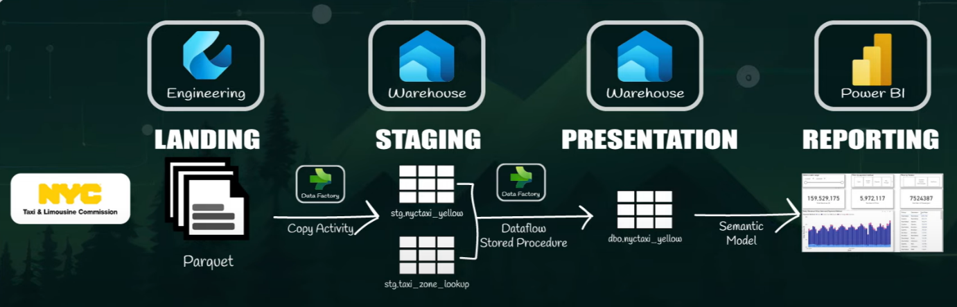

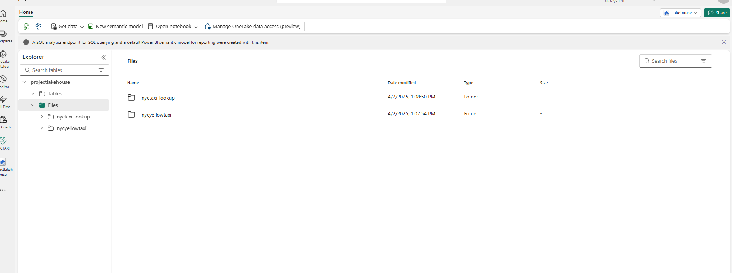

**Landing**

* **Source**: NYC TLC trip record data in **Parquet** format.
* **Storage**: Data is landed in a Fabric Data Lakehouse.

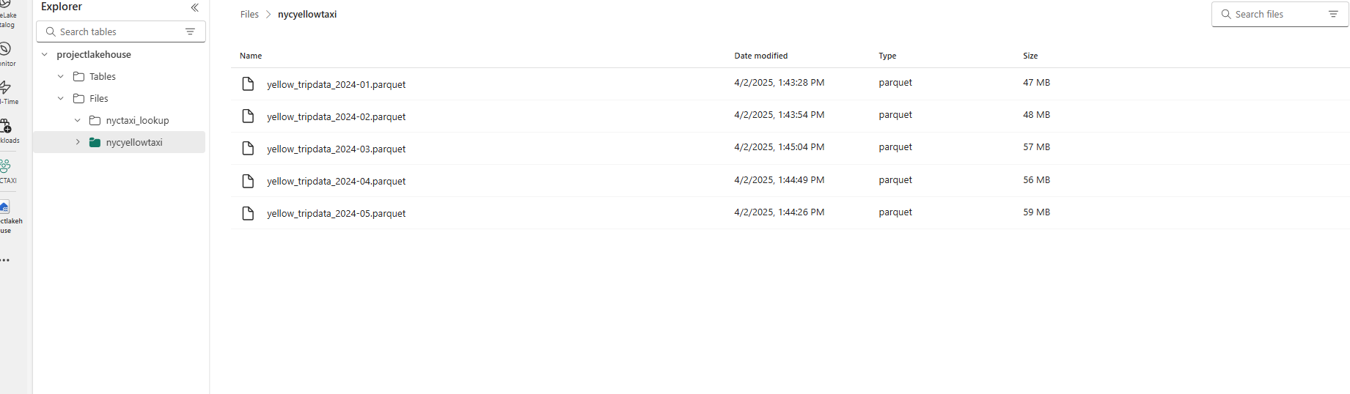

In fabric lakehouse where all month taxi trip data contains trip distance trip mode pickup date

Drop off time payment mode vendor id total passenger

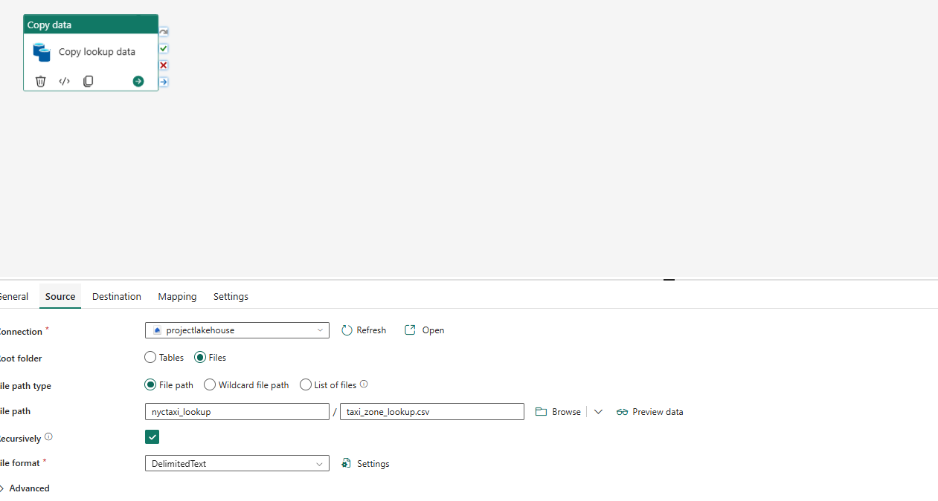  
in copy data we move data from lakehouse external file to warhouse table   
  
  
  
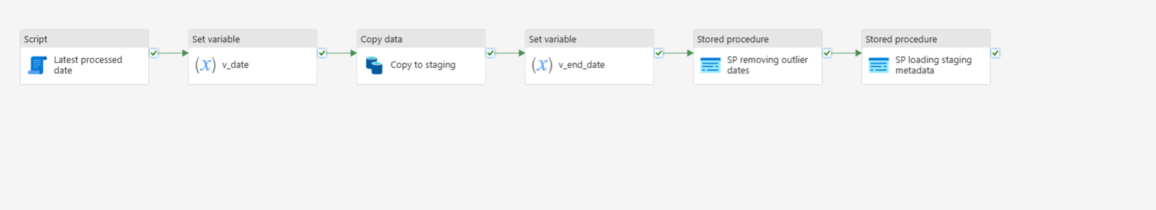

We set a **dynamic parameter** to store the variable v_date as @formatDateTime(addToTime(activity('Latest Processed Date').output.resultSets[0].rows[0].latest_processed_pickup, -1, 'Month'), 'yyyy-MM') so that v_date represents the **previous month**, and in the **Copy Activity** for staging nyc_yellowtaxi, we pass this parameter in the **source file name and path** as @concat('yellow_tripdata_', variables('v_date'), '.parquet') to dynamically select the correct file, while the **destination table** in the warehouse is stg.nyctaxi_yellow, and we store another variable @addToTime(concat(variables('v_date'), '-01'), 1, 'Month') to set the **next month as v_end_date**, followed by executing a **Stored Procedure (SP) to remove outliers** from the dataset.

create procedure stg.data_cleaning_stg

@end_date datetime2,

@start_date datetime2

As delete from stg.nyctaxi_yellow where tpep_pickup_datetime < @start_date or tpep_pickup_datetime > @end_date;  
this procedure will delete pickuptime nextmonth and end date should less than that month

In sp meta data we create sp   
CREATE PROCEDURE metadata.insert_staging_metadata

@pipeline_run_id VARCHAR(255),

@table_name VARCHAR(255),

@processed_date DATETIME2

AS

INSERT INTO metadata.processing_log (pipeline_run_id, table_processed, rows_processed, latest_processed_pickup, processed_datetime)

SELECT

@pipeline_run_id AS pipeline_id,

@table_name AS table_processed,

COUNT(*) AS rows_processed,

MAX(tpep_pickup_datetime) AS latest_processed_pickup,

@processed_date AS processed_datetime

FROM stg.nyctaxi_yellow;   
we insert column pipeline_run_id, table_processed, rows_processed, latest_processed_pickup, processed_datetime and store the value

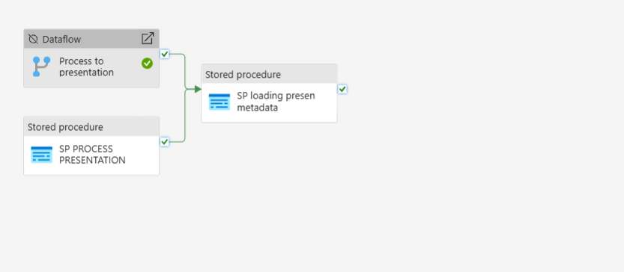

In sp process presentation   
CREATE PROCEDURE dbo.process_presentation

AS

INSERT INTO dbo.nyctaxi_yellow

SELECT

CASE

WHEN nty.VendorID = 1 THEN 'Creative Mobile Technologies'

WHEN nty.VendorID = 2 THEN 'VeriFone'

else 'Unknown'

end as vendor,

format(nty.tpep_pickup_datetime,'yyyy-MM-dd') as tpep_pickup_datetime,

format(nty.tpep_dropoff_datetime,'yyyy-MM-dd') as tpep_dropoff_datetime,

lu1.Borough as pu_borough,

lu1.Zone as pu_zone,

lu2.Borough as pu_borough,

lu2.Zone as pu_zone,

CASE

WHEN nty.payment_type = 1 THEN 'Credit Card'

WHEN nty.payment_type = 2 THEN 'Cash'

WHEN nty.payment_type = 3 THEN 'No Charge'

WHEN nty.payment_type = 4 THEN 'Dispute'

WHEN nty.payment_type = 5 THEN 'Unknown'

WHEN nty.payment_type = 6 THEN 'Voided Trip'

else 'Unknown'

end as payment_method,

nty.passenger_count as passenger_count,

nty.trip_distance as trip_distance,

nty.total_amount as total_amount

from stg.nyc_taxi_yellow nty

left join stg.taxi_zone_lookup lu1

on nty.PULocationID = lu1.LocationID

left join stg.taxi_zone_lookup lu2

on nty.DOLocationID = lu2.LocationID;  
 and den do some sort of join and change numeric value to assign categorical name and den connected to sp loading metadata   
  
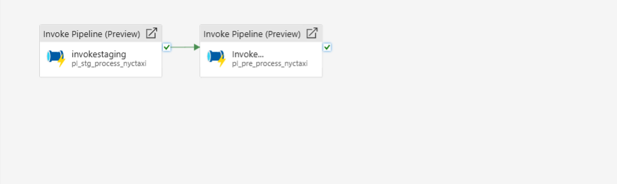

In the invoke staging step, we call the stored procedure pl_stg_process_nyctaxi and pass the data to pl_pre_process_nyctaxi, enabling continuous monthly data fetching from the Lakehouse to the warehouse, which is connected to a semantic model for building Power BI reports.warehouse, which is connected to a semantic model for building Power BI reports.